
April 2012 Volume VI, No. 2
Among Friends

WELCOME, NEW MEMBERS  Orysia Karapinka  Ellen Price  Shelley Ross  Annual Meeting and  Program for All Ages  Sunday, June 3 at 2 pm  in the Main Meeting Room  After a brief business meeting and election of officers, the Friends of the Squirrel Hill Library will present ventriloquist  Cindy Speck and her friends:    Her interesting and entertaining program includes humor, songs, and audience participation for both kids and adults.  Refreshments will follow. | Now that we have the resources necessary to keep our libraries operational – thanks to Pittsburgh voters – we can take the opportunity to stand back and think about the reasons why libraries were created in the first place.  Andrew Carnegie, the founder of our Pittsburgh library system, felt that all individuals should be given the chance to learn and to find out all that the world has to offer. Carnegie wrote about his views on social subjects and the responsibilities of great wealth in Triumphant Democracy (1886) and Gospel of Wealth (1889). He wrote, “It is the mind that makes the body rich”. He devoted the rest of his life, after making his money, to providing the capital for purposes of public interest and social and educational advancement.  His first library was opened in Dunfermline, Scotland in 1883; in 1885 he gave $500,000 to Pittsburgh for a public library on condition that the local authorities give land and a budget to provide for operation and maintenance. In total Carnegie funded more than 3,000 libraries in 47 states and other countries.  Over the past decades, libraries have expanded both their offerings and their functions. They provide computers for those who need access to the world wide web; movies, music and magazines for those who want to stay current and entertained; and, most recently, E-books for those who prefer their reading to be electronic. Our libraries also have information on research and development. Carnegie would be proud if he could see how what he started has grown and kept pace with the changes in our world. Ten years from now, libraries may again look very different.  Take a moment to think about all that you have access to at your library, and I am sure that you will agree that libraries are a wise investment.  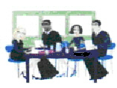  Saturday, April 14, 10 AM  Saturday, May 5, 10 AM  Sunday, June 3, 2 PM  (annual meeting/program)  You’re Invited  to our  Friends’ Meetings
  PRESIDENT’S  MESSAGE  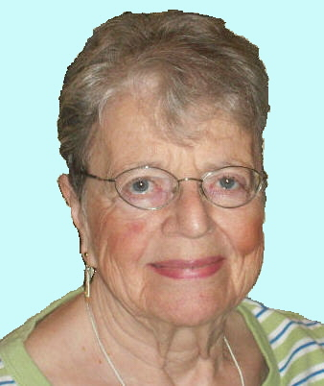  Joan Schwartzman | A Book  There is no frigate like a book  To take us lands away,  Nor any coursers like a page  Of prancing poetry.  This traverse may the poorest take  Without oppress of toll;  How frugal is the chariot  That bears a human soul!  Emily Dickinson-1830-1886
Improved Hours: You Asked For Them,
You Worked For Them, You Got Them!

Thanks to the work of the Friends of the Library and other citywide library supporters, the library has been able to respond to the need for more available library hours across the city. Those libraries that had been open only 4 days a week due to decreased funding from the state are now back to a 6 day schedule! Here in Squirrel Hill we’re finally able to be open until 8:00 again a few nights a week. These expanded hours will enable us to once again bring you evening programs. Please note that we’ve also swapped our Monday and Thursday closing times so that we more closely match the business district hours.

New Squirrel Hill Library Hours:
Mon 10-5 | Thur 10-8 | Sun 1-5
Tue 10-8 | Fri 10-5
Wed 10-8 | Sat 10-5

For a list of the hours at all library locations go to http://www.carnegielibrary.org/locations/hours.pdf

It is never too late to be what you might have been. George Eliot 1819-1880
Published by the Friends of the Squirrel Hill Library, 5801 Forbes Avenue, Pittsburgh, PA 15217
editor: Joan Schwartzman mailing list: Allison Marciszyn production: Dean Damick, Marion Damick, Rita Motor, Margie Spenser, Serena Spenser
websites: www.carnegielibrary.org/locations/squirrelhill and www.pittsburghusedbooks/friends
e-mail: friends@pittsburghusedbooks.com membership email: SqHiFriendsLib@gmail.com
April 2012 Among Friends Volume VI, No. 2
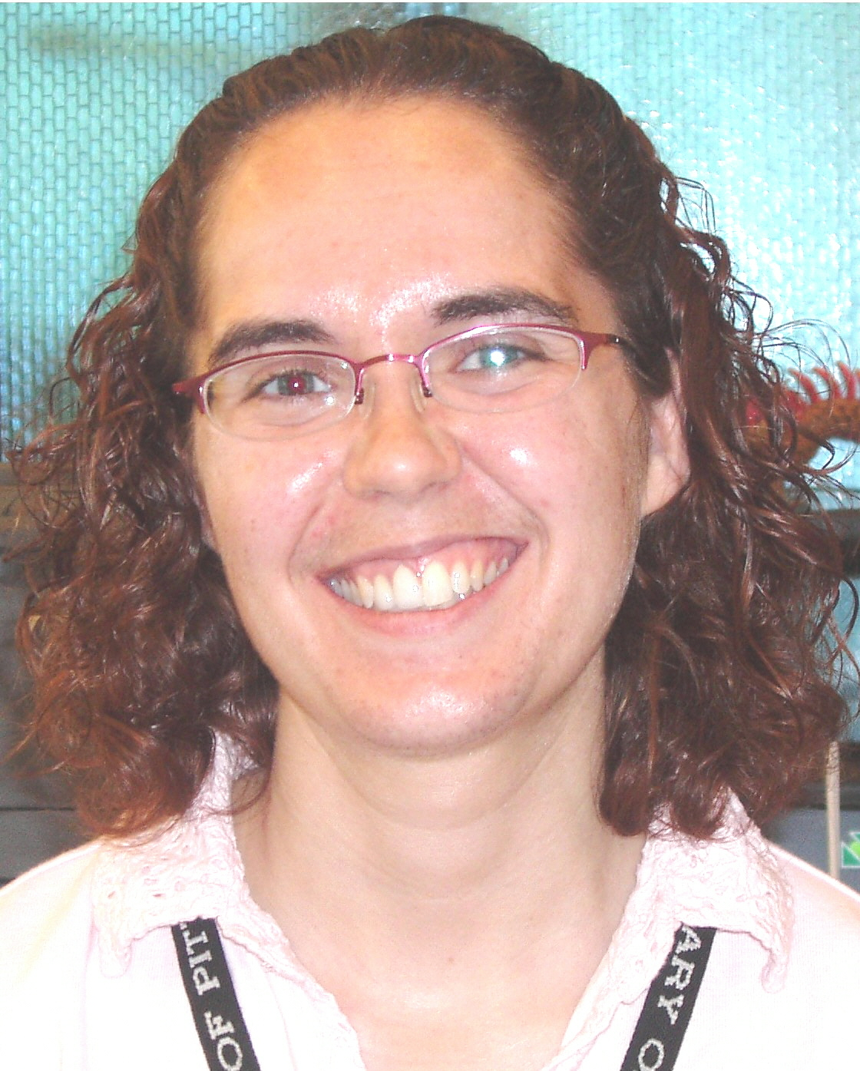  Megan | Children’s Department Happenings  by Megan Fogt, Manager of Children’s Services  and Rachel Nard, Children’s Librarian  While we have enjoyed reading lots of stories about snow in the children’s department this winter, we are looking forward to blue skies and warmer weather. Here are a few programs that will help you survive the winter blahs. |  |   Rachel
A great book for “thinking spring” is Stop Snoring, Bernard!, this year’s choice for Pennsylvania’s “One Book, Every Young Child” initiative. This program is part of a statewide collaboration among librarians and early-childhood educators to highlight the importance of early literacy activities for preschoolers.

Sleepy otter Bernard spends much of his time trying to find a peaceful place to rest where his sonorous snoring won’t bother his fellow zoo animals. Although he starts out sad and lonely on his journey to find a comfy snoozing spot, Bernard finds happiness and makes new friends. Written and illustrated by Zachariah Ohora, Stop Snoring, Bernard! celebrates the joys of discovering true friendship and loving
 |  | others just the way they are. Thanks to the generous funding of the Friends of the Squirrel Hill Library, we are able to give out copies of this book to every early-childhood and kindergarten classroom in our service area!  Join us for an Outrageous Otter Occasion for the whole family as we share fun stories, songs, and other activities based on Stop Snoring, Bernard! on Thursday, April 26th from 6:00 – 7:00 PM.  The staff of the Children’s Department is also thinking warm thoughts as we prepare for this year’s Summer Reading Club. We are dreaming of a potential penguin visit, blasting off on a rocket ship into the night sky, and traveling the world to discover new species of nocturnal animals. The sky’s the limit! That’s right, the 2012 theme is “Dream Big—READ!” Save the date for our 12th Annual Summer Reading Extravaganza which will be held outside the Main Library in Oakland on Sunday, June 10th from 12-5 p.m. Besides enjoying many free family activities and a Book Sale tent, you

can sign up for Summer Reading.* We will continue to most new information about our Summer Reading programs on our website at www.carnegielib rary.org/kids/events.  Children’s Literature News  The 2012 Newbery and Caldecott award winners were announced in January. The 2012 Newbery Medal winner is Dead End in Norvelt by Jack Gantos. The Caldecott Medal was awarded to A Ball for Daisy, illustrated and written by Chris Raschka. For more details, visit our website at http://www.carnegielibrary.org/kids/books/award winners.cfm. The Sydney Taylor Book Awards were also awarded earlier this year by The Association of Jewish Libraries. The 2012 winners are: Chanukah Lights by Michael J. Rosen with artwork by Robert Sabuda (for younger readers), Music Was It: Young Leonard Bernstein by Susan Goldman Rubin (for older readers), and The Berlin Boxing Club by Robert Sharenow (for teens). To read more about these titles and awards visit http://www.jewishlibraries.org/main/Awards/SydneyTaylorBookAward.aspx.  Check out more information about these and other great books on our website or stop by the library.  Middle School and High School Volunteers Needed  Do you know a teen who loves kids and crafts? CLP – Squirrel Hill is looking for middle school and high school volunteers to help us with our weekly craft club during the summer. The programs are on Wednesday afternoons from  3-5 pm. Email Megan Fogt at fogtm@carnegielibrary.org for more information. |   *For information about the Teen and Adult  Summer Reading programs, see page 5.

Welcome Our New Teen Librarian, Maddie Siegel

Thanks to the added money from the tax referendum, we are pleased to be able to add a  new Teen Librarian to our youth services staff at CLP – Squirrel Hill. Maddie Siegel’s first day was in March, and she is already working on programs for this summer. She was the head Children’s and Teen Librarian at the Peters Township Public Library; we are excited about all the fantastic programs she has done with teens there, and to see what new programming she will bring here. So, if you have a teen in your life, encourage him/her to stop by and say “hi” to Maddie. Here are three fun facts about her:  1. She lived in New York City for six years before moving to Pittsburgh.  2. She’s ridden a camel!  3. Her favorite sport is swimming. | 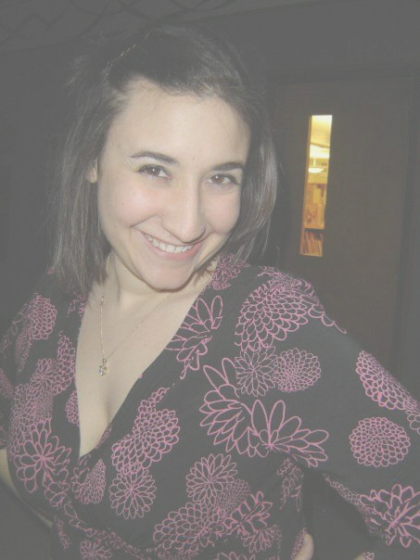


need a new saying

Some people are always grumbling because roses have thorns.
I am thankful that thorns have roses. Alphonse Karr

April 2012 Among Friends Volume VI, No. 2

 | In My HumbleOpinion  by Margie Spenser  Newsletter Tech Staff  I’m always eager to encourage our members to contribute money to the Friends (to support | 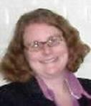 | Gardening Thyme:  Community Gardens at the Library  by Holly McCullough  Manager, Carnegie Library of Pittsburgh  – Squirrel Hill  We’re excited to announce that the Squirrel Hill

our own branch) or to the Carnegie Library of Pittsburgh (to help the entire system). An easy way to donate to CLP is to sign up for a Donor card instead of the basic free library card. Besides a feeling of generosity and good sense, it gives you some neat perks. The most recent Discover the Library program was a guided tour of the CLP Support Center to see how new acquisitions are chosen, processed, and sent to their new homes. You missed your chance to sign up to attend if you weren’t on the Donor Plus card emailing list!  IMHO, good pop fiction writers seem to be unable to pass their talents down to their children. I just finished reading Shadow Zone by Iris Johansen and her son Roy. It’s very similar to her usual romantic thrillers, but the characters were hollow and boring. His fault? I couldn’t even finish the one book I tried by Faye and Jonathan Kellerman’s son Jesse. Felix Francis’ collaborations with his father, Dick, and the mysteries he is now writing alone are okay, but have nothing like the magic of plot and language that his parent(s) produced. Of course, Dick’s last book “alone”, published after his wife died, was so different from his usual work that I knew she hadn’t had a hand in it. Dick was right – she should have had her name on his books as co-author. See www.eurocrime.co.uk/reviews/Gamble.html.  What’s your HO on this? Have you read any good second-generation authors lately? Tell me about it at Margie@pittsbur ghusedbooks.com. | library is one of several Carnegie Library of Pittsburgh locations which have received a Mary Jane Berger Memorial Foundation grant to create community gardens and supporting collections. These gardens will serve to educate people about the benefits of community and home gardening and, with a focus on herbs, will bring attention to the positive role of herbs in medicine, cooking and more. The sites selected for the gardens are the CLP locations in Homewood, Knoxville, Lawrenceville, Mount Washington, Sheraden, Squirrel Hill, West End and Woods Run. The focus will be on edible plants (vegetables and herbs) and the gardens will range from very small to rather large. Here in Squirrel Hill we’re planning on doing some raised bed gardening in our backyard area adjacent to the children’s section and meeting rooms.  We hope the gardens will provide the opportunity for community interaction and intergenerational programming, and we are currently seeking partners to help us to create and maintain the gardens and to plan and implement programs on relevant topics.  Work on the gardens will begin as soon as possible, with planning taking place in the late winter and early spring and planting and maintenance occurring at the appropriate time in the early summer.  If you have any gardening expertise or are interested in programming please give us a call at 412-422-9650 or e-mail squirrelhill@carnegielibrary.org.

A little madness in the Spring is wholesome even for the King. Emily Dickinson 1830-1886
Keeping Up-to-Date With Teen Services  We’re doing a lot of things in Teen Services – book discussions, special programs, poetry workshops and writing contests, not to mention everyday things such as writing book reviews, creating booklists and visiting schools. Of course, right now we are starting to plan our Summer Reading programs.  How can anyone keep up with all that is going on?  Well, we have a lot of digital/social media sites to help inform people about what we are doing. Any one of these will tell you about all the exciting things we are doing in Teen Services:prin white to format c  OUR WEBSITE – http://www.carnegielibrary.org/teens/ Here we have booklists, book reviews by staff and teens, homework help resources, polls, and events listings.  OUR BLOG – http://clpteensburgh.org/ You’ll find teen- interest articles, book reviews, news articles, and events promotion.  FACEBOOK – https://www.facebook.com/clpteen Here we promote events, update our users when we post something to our blog or add a new feature to our web-site, and share some fun internet stuff.  OUR TWITTER ACCOUNT -- @CLP_Teens – if keeping up with any of the above seems too much, just follow our twitter account. Here we’ll keep you up-to-date with what we are posting, our events, and some good old-fashioned fun stuff, 140 characters at a time. | Local Author by Allison Marciszyn  eating her way through Pittsburgh (NY Journal of Books). But “to say Aftertaste is a story about food and love and resilience is like calling Anthony Bourdain ‘a cook’” (Jo-Ann Mapson).  A developmental psychologist, Mileti draws from her professional experience to build her characters, and the local food scene and her Italian heritage to season her book with a selection of traditional recipes tested in her Mt. Lebanon kitchen.  Meredith Mileti will give a book talk and signing  at 1:00 PM on Tuesday, June 12 at the Squirrel Hill Library.  Refreshments to follow (of course).  Come stop in for a bite!
  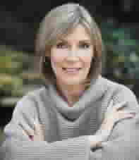 | A Fresh Taste of Pittsburgh  In Aftertaste: a Novel in Five Courses, local author Meredith Mileti has dished up a passionate debut novel about top New York chef Mira Rinaldi, who returns to her Squirrel Hill roots, new baby in tow, after her husband and
  business partner cooks up an affair with their new waitress. With friends, family and the local culinary scene, Mira has the opportunity to start over, and an unexpected chance to regain her losses.  With “a wonderfully flawed narrator with an ax (and an ex) to grind” (Liza Gyllenhaal), Aftertaste takes us through scores of wonderful scenes of Mira either cooking up a storm or |  | 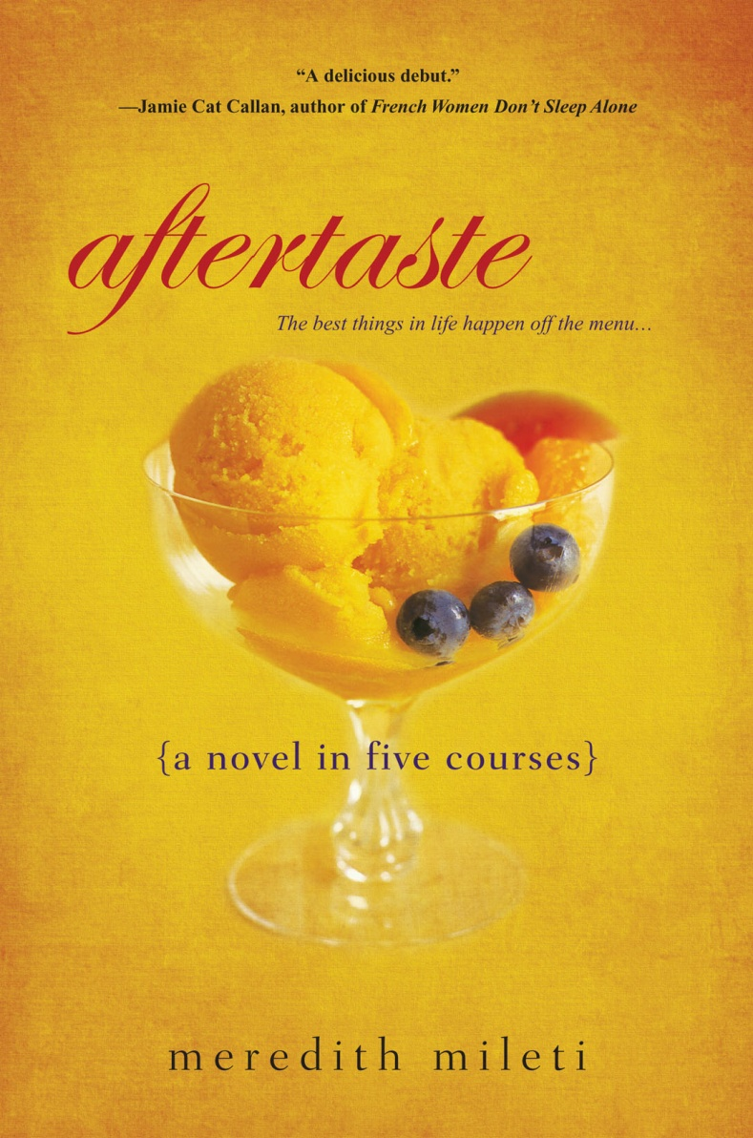  A little madness in the spring is wholesome even for the King.  Emily Dickinson 1830-1886

April 2012 | Among Friends |  | Volume VI, No. 2
April 11, 6:30 PM
 | NAMM BUSINESS CENTER PROGRAMS  April – June 2012  by Dorothy Kabakeris, Namm Business Center Librarian  All programs are scheduled for Wednesday  from 10:15 to 11:00 AM or at 6:30 PM | 
401(k)s: What are the Options and Inherent Flexibilities in Your 401(k)?
If you just started a job, switched to another job, or left a job, learn how you can manage the profits from your 401(k).
Presented by Aldo Pomposini and Mike Corcetti,
Financial Representatives, Northwestern Mutual Financial Network
Note that this program was scheduled at 6:30 after our new extended hours were announced,
to accommodate people coming home from work.
The other programs had already been scheduled and therefore take place at the earlier time.

May 23, 10:15 AM
Retire, Rewire, Renew; Explore and Plan for Your Future.
Whether you’re retired and exploring how to be most satisfied or considering retirement, this program is for you.
You can reinvent yourself into a new job or enjoy time with volunteering and hobbies. Learn about the
five paths of retirement and use a model for planning to help you make choices for greater happiness.
Presented by Karen Litzinger, MA, Litzinger Career Consulting

May 30, 10:15 AM
Doing Business With the Federal Government
Get a basic understanding of the federal procurement process. Topics to be addressed include registrations and
certifications, identifying NAICS and service codes, size standards and procurement opportunities.
The government might be your best customer!
Presented by Debbie Wojucik, Director of the Government Agency Coordination Office,
California University of Pennsylvania
June 20, 10:15 AM
Interviewing 101
Learn interviewing techniques, how to negotiate offers, and how to
transition into a new position. Helpful checklists and tips will be provided.
Presented by Joseph P. D’Anna, Counselor, Career Development Center

To receive the Namm monthly bulletin featuring news  and a list of new books, ask to be put on the e-mail list.  Contact Namm Librarian Dorothy Kabakeris  at 412-422-9650 or squirrelhill@carnegielibrary.org  SCORE - Small Business Assistance –  Schedule: first Monday of every month,  10:00 AM - 1:00 PM  April 2, May 7, June 4  Book Talk and Book Signing:  Tuesday, June 12 @ 1:00 PM  Pittsburgh author Meredith Mileti will present her  new book Aftertaste : a novel in five courses.  For more information, see page 3.  I loathe the expression “What makes him tick”. It is the American mind, looking for simple and singular  solution, that uses the foolish expression. A person not only ticks, he also chimes and strikes the hour,  falls and breaks and has to be put together again, and sometimes stops like an electric clock in a  thunderstorm.  James Thurber 1894-1961 |  | The Squirrel Hill  Adult Book Discussion Group  meets at 1:00 PM on the fourth Thursday of the month.  All are welcome.  April 26  Loving Frank  a novel by Nancy Horan, 2007  May 24  Cutting for Stone  a novel by Abraham Verghese, 2009  June 28  In the Garden of Beasts: love, terror,  and an American family in Hitler’s Berlin  by Erik Larson, 2011

April 2012 Among Friends Volume VI, No. 2

 | Film,  Fiction,  Fun  by Mark Russell, Librarian   |  |  | Coming up are:  April: Lea Black photos  Tamara Shasko silk paintings  May: Milestone Group various media  June: Sherry Sigel watercolor & acrylic involving Hebrew characters  Our schedule for artists is full through March, 2013!  If you are interested in exhibiting after that, contact Marion Damick,  412-521-3075.  Squirrel Hill Books on eBAY  Go to eBAY.com. Click "Advanced"  (next to Search). Click "By Seller".  In the"Enter sellers user ID"  box, type friendsoftheshlibrary2011  . Click “search” at the bottom of the  page. Click on any item to see  details.  And on Amazon  Go to AMAZON.com. Select Books  in the Search box. Type Woody  Flora of Taiwan (one of the  Friends’ offerings) to the right, then  click Go. Choose “unknown binding”  and click on one of the links to  “sellers” or ”3 used”, etc. In the  results find the copy for sale  by friendsoftheshlibrary2011.  Click on that name to see other  items for sale.  Candidates for Friends Office  Marion Damick President President  Marilyn Honigsberg Vice President  E Eleanor Hershberg Treasurer  Rita Motor Secretary  The Annual Meeting on June 3 will  feature the election of officers for the next year. The incumbant officers  have been nominated for reelection,  with the exception of current President  Joan Schwartzman, who is ready for  a rest. Nominations from the floor are  also welcome.
  Art at the
  Squirrel Hill Library
  
Film, Fiction, and Fun is a special series presented at the Carnegie Library of Pittsburgh – Squirrel Hill on the third Thursday of each month from 1 to 4 p.m. It explores the relationship between films and the novels that inspired them. Attendees are encouraged to read a monthly fiction selection, then join CCAC’s Jeanne Bergad for a screening of the film and discussion to follow.

April 19th’s title is Push, by Sapphire. Precious, the protagonist of Sapphire’s 1996 debut novel, is sixteen years old, functionally illiterate, and pregnant with her second child. Her pregnancy causes her high school principal to transfer her to an alternate school, and under the care of her new teacher, Ms. Rain, she begins to learn how to read and write. Precious’ new educational pursuits and the birth of her son become a catalyst for liberation from her abusive home. Lee Daniels directed Precious, the 2009 film version of Push, and his film won two Academy Awards. One was for the screenplay adaptation by Geoffrey Fletcher, and the other was for the supporting actress performance of Mo’Nique in the role of Precious’ mom.

May 17th’s book is The Stoning of Soraya M, by Freidoune Sahebjam. This international bestseller tells the true story of one of the victims of stonings in modern Iran. Soraya Manutchehri's husband Ghorban-Ali is an ambitious man, prone to fits of rage. He wants a way out of his marriage in order to marry a 14- year-old girl but does not want to support two families. When Soraya begins cooking for a local widower her husband finds a way to achieve his goal. Abetted by corrupt village authorities, he accuses his wife of adultery. She is convicted, buried up to her waist, and stoned to death. The 2008 film was directed by Cyrus Nowrasteh and starred Mohzan Marno in the role of Soraya.

June 21st’s selection is The Reader, by Bernhard Schlink. Schlink’s 1996 book is the first German novel to top the New York Times Bestseller list. It follows three distinct time periods in the lives of a 15-year-old boy and a former SS guard who engage in an unlikely affair. The 2008 film, directed by Stephen Daldry, snagged a best actress Oscar for Kate Winslet in the role of the former guard, Hanna Schmidt.

  FILM, FICTION, FUN  April 19: 1 pm Push  (filmed as Precious)  May 17: 1 pm The Stoning  of Soraya M.  June 21: 1 pm The Reader  moderator  Jeanne Bergad | If this nation is to be wise as well as strong, if we are to achieve our destiny, then we need more good ideas for more wise men reading more good books in more public libraries. These libraries should be open to all — except the censors.  John F. Kennedy- 1917-1963
3
CAN SAY A LITTLE BIT HERE ABOUT TEEN AND ADULT SUMMER READING PROGRAMS, HOW TO SIGN UP, WHAT PRIZES ARE AVAILABLE, ETC. DO WE HAVE RECORDS OF HOW MANY BOOKS THE “READINGEST” FOLKS READ LAST YEAR?
As this is written, we don’t know yet what prizes and incentives are going to be available for
Teens and Adults who join the Summer Reading Program, but we know there will be some.
For details about the Teen program, come in and talk to Maddie Siegel, our new Teen Librarian
(siegelm@carnegielibrary.org). Adults can get info from any Reference Librarian at his/her desk.

CARNEGIE LIBRARY OF PITTSBURGH  — SQUIRREL HILL |  | 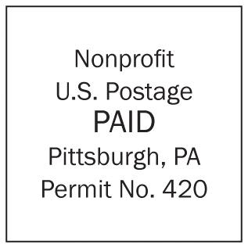  If you PREFER not to  get a printed copy of the  newsletter, send your  email address to Allison  at the address on the  membership form below.
5801 Forbes Avenue  Pittsburgh, PA 15217  Adult Services: 412-422-9650  9841  Children's Services: 412-422-  Fax: 412-422-5811  www.carnegielibrary.org/clp/sq  Is your Friends Membership up to date? Please check your mailing label/membership card ➔  If the date is before 04/12, you need to renew. Mail us the form below.  Reading – the best state yet to keep absolute loneliness at bay. William Styron 1925- | ADDRESS SERVICE REQUESTED  your donation is tax deductible as a charitable contribution
  
  <<exptxt>>  <<expdte>> | <<first>> <<last>>  <<addr>>  <<city>>, <<st>><<zip>>-<<zip4>>

xyzxyz

April 2012 Among Friends Volume VI, No. 2

Make checks payable to:  Friends of the Squirrel Hill Library  and mail to:  Allison Marciszyn  1914 Murray Avenue, #24  Pittsburgh, PA 15217  SqHiFriendsLib@gmail.com  Check one box:  New Member Renewal  Check one or two boxes:  $5.00 $10.00 $15.00  $25.00 $50.00 Other ____  DONOR (the first year is free, but we  gladly accept donations.)  Name:____________________________________  ^{(Last)} ^{(First)}  Address: _________________________________  City/State: __________________Zip: __________  Phone(s): ___________________Date: _________  E-mail address: ____________________________  Please check all activities you can help with:  Periodic Book Sales Library Advocacy  Sorting Used Books Gardening  Adopt-a-Shelf Program Newsletter  COMMENTS________________________  _______________________________  _______________________________  The average pencil is seven inches long, with just a half-inch eraser –  in case you thought optimism is dead.  Robert Brault
  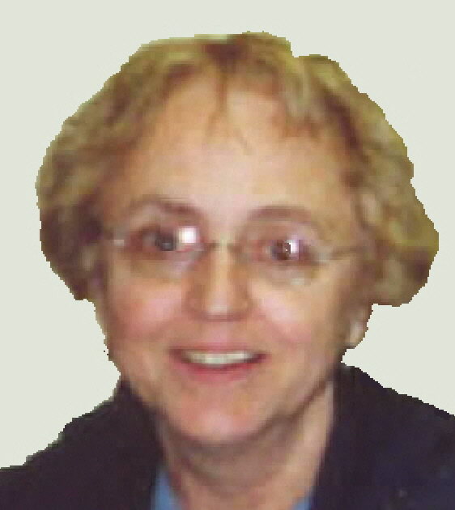  Pat Bender | Friends Book Sale Committee  Takes the Plunge into Online Waters  We have been selling books on eBAY and Amazon for several months. Through February we sold 15 books for a total of
  $450. We currently have about 130 books listed for sale, and we are looking for sales to increase as we offer more and more items. To see details on our current offerings, follow the directions on page 5.
  Our scheduled sales and the ongoing sale continue to be solid sources of revenue for the Friends of the Library. The Spring Sale will start on April 26 and end on April 29. All of our regular holdings plus some special items will be for sale. We are also having a flea market that promises interesting stuff, so we are asking for donations of small household items, both useful and decorative; games; puzzles; bric-a-brac; jewelry; etc. Please bring donations to the back of the Library, near the Friends’ room.
  Your donations are our life's blood, so keep the transfusions coming, please. However, among the book donations to Friends, we have found a surprising number that have a moldy odor. Sources tell us that such books are a health hazard and that there is no way to reverse the damage. We have tried sunshine, freezing, microwaving, and burying the books in kitty litter. Instead of condemning your valuable books to storage to get moldy, donate them to the Friends.  We also need bubblewrap and small boxes for mailing books. | 

